Final Report
1. INTRODUCTION
1.1 Project Overview
The Credit Card Approval Prediction System is a machine learning-based web application designed to predict whether a credit card application is likely to be approved or rejected, based on an applicant's personal and financial information. The system uses a Random Forest Classifier trained on historical credit card application data, analyzing 12 key features such as age, annual income, employment duration, education, family status, and housing type. The application is built using Flask as the backend framework, with a clean and responsive HTML/CSS-based frontend. Users enter their details through a simple web form, and the system instantly displays the prediction result along with a confidence score and a structured applicant summary.
1.2 Purpose
The purpose of this project is to automate and simplify the credit card approval process using machine learning. Traditionally, credit card approval decisions are made manually by bank officials after reviewing an applicant's financial background, which can be time-consuming and inconsistent. This system aims to:
- Reduce the time taken to assess credit card applications.
- Provide consistent, data-driven approval decisions.
- Minimize human bias in the approval process.
- Offer applicants instant feedback with a confidence score.
- Serve as a practical demonstration of the end-to-end machine learning workflow — from data preprocessing to web deployment.

2. IDEATION PHASE
2.1 Problem Statement
Financial institutions receive a large volume of credit card applications daily. Manually reviewing each application based on income, employment, education, and other financial indicators is time-consuming, inconsistent, and prone to human error or bias. Applicants also face long waiting periods without any immediate indication of their approval likelihood. There is a need for an automated, reliable, and fast system that can predict credit card approval outcomes based on historical data patterns, helping both financial institutions and applicants.
2.2 Empathy Map Canvas
User: Bank Loan Officer / Applicant
Category | Details
Says | "I want to know quickly if I qualify." / "Application review takes too long."
Thinks | "Will my income and job type affect my approval?" / "Is there a faster way to evaluate applications?"
Does | Fills out application forms manually / Waits for approval / Manually cross-checks applicant data
Feels | Anxious about approval outcome / Frustrated with delays / Overwhelmed with application volume
Pain Points | Long processing time, inconsistent decisions, lack of transparency in rejection reasons
Gains | Instant prediction, transparency through confidence score, faster decision-making, reduced manual workload

2.3 Brainstorming
Ideas generated during the ideation phase:
- Build a machine learning model to predict approval based on historical applicant data.
- Use a web interface for easy data entry instead of paper-based forms.
- Provide a confidence score along with the prediction for transparency.
- Include input validation to prevent incorrect or unrealistic data entry.
- Display an applicant summary for record-keeping and verification.
- Use dropdown menus for categorical fields to reduce input errors.
- Make the interface responsive so it works across desktop, tablet, and mobile.
- Add a timestamp to each prediction for tracking purposes.
- Allow users to easily re-submit a new application using a "Predict Again" feature.
Selected ideas were prioritized based on feasibility, impact, and relevance to the core objective, leading to the final feature set of the application.

3. REQUIREMENT ANALYSIS
3.1 Customer Journey Map
Stage | Awareness | Consideration | Application | Prediction | Outcome
User Action | Learns about the online credit card prediction tool | Decides to check eligibility before applying at a bank | Fills in personal & financial details in the form | Clicks "Predict Approval" | Views result, confidence score, and summary
Touchpoint | Website/App Landing Page | Home Page Form | Applicant Details Form | Prediction Engine (Flask + ML Model) | Result Page
User Emotion | Curious | Hopeful | Slightly anxious | Waiting | Relieved / Informed
Opportunity | Clear, simple UI to build trust | Guided input with dropdowns | Real-time validation | Fast response time | Clear result with actionable summary

3.2 Solution Requirement
Functional Requirements:
- User should be able to input personal and financial details through a web form.
- System should validate all inputs before processing.
- System should predict approval/rejection using a trained ML model.
- System should display a confidence score with the prediction.
- System should display a structured applicant summary.
- System should display the date and time of prediction.
- User should be able to submit a new prediction without restarting the application.
Non-Functional Requirements:
- Usability: Simple, intuitive, and responsive interface.
- Performance: Prediction result should be generated within 3 seconds.
- Reliability: The model should give consistent results for the same input.
- Scalability: The system should handle multiple concurrent users.
- Availability: The application should be accessible without downtime.
- Security: Input data should be validated to prevent invalid or malicious entries.
3.3 Data Flow Diagram
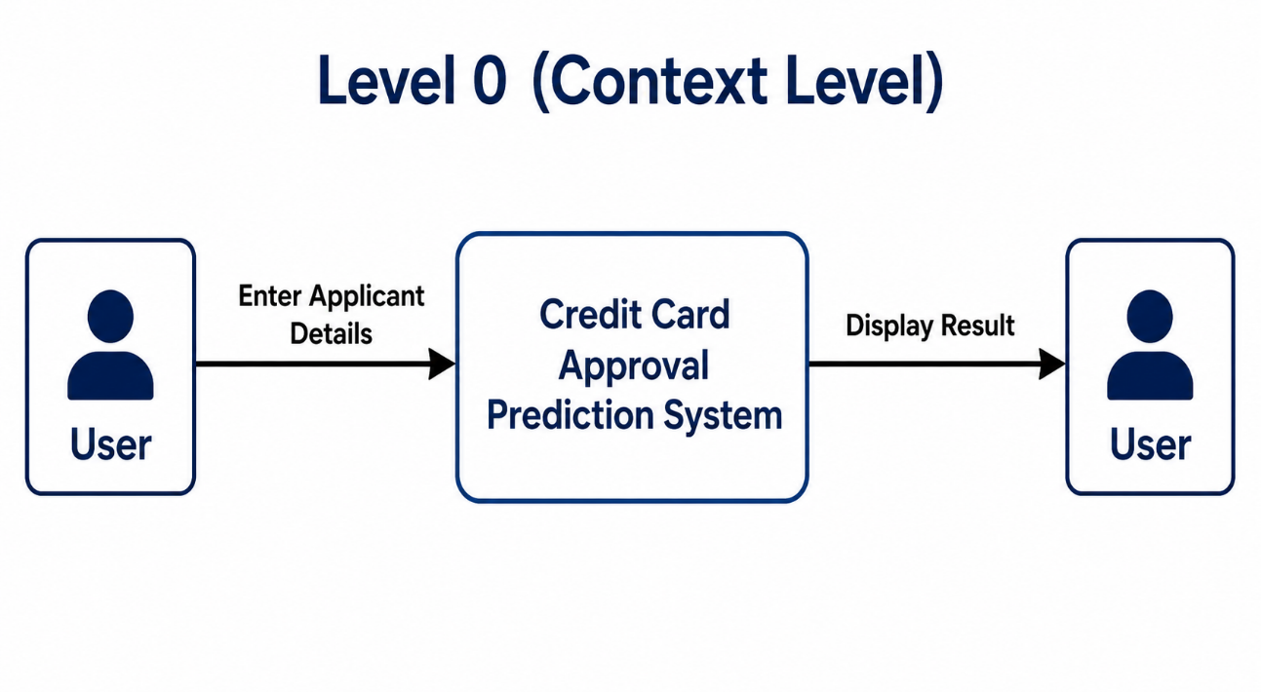
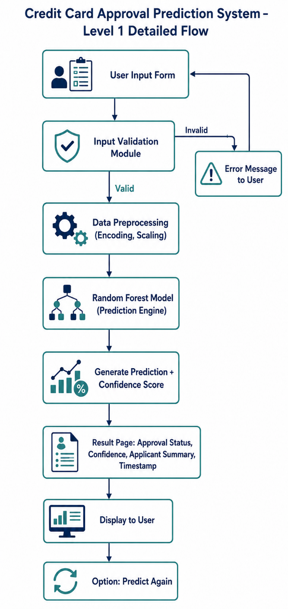
3.4 Technology Stack
Layer | Technology
Frontend | HTML5, CSS3
Backend | Flask (Python)
Programming Language | Python
Data Handling | Pandas, NumPy
Machine Learning | Scikit-learn
ML Algorithm | Random Forest Classifier
Model Storage | Pickle (.pkl)
IDE | VS Code / Jupyter Notebook
Version Control | Git & GitHub
4. PROJECT DESIGN
4.1 Problem Solution Fit
Problem | Solution
Manual review of credit card applications is slow | Automated ML-based prediction gives instant results
Inconsistent decision-making due to human bias | Data-driven model ensures consistent evaluation
Applicants lack transparency in approval outcome | Confidence score provides transparency
Risk of incorrect data entry | Input validation prevents invalid submissions
Difficulty tracking application history | Applicant summary and timestamp maintain records

4.2 Proposed Solution
Parameter | Description
Problem Statement | Manual credit card approval is slow, inconsistent, and lacks transparency.
Idea / Solution Description | A Flask-based web application that uses a trained Random Forest Classifier to predict credit card approval based on 12 key applicant features, providing instant results with a confidence score.
Novelty / Uniqueness | Combines real-time input validation, confidence scoring, and a structured applicant summary in a single lightweight web app.
Social Impact / Value Proposition | Reduces processing time for financial institutions and gives applicants quick, transparent feedback.
Business Model | Can be integrated into banking systems as a pre-screening tool before formal application processing.
Scalability | The model and Flask app can be scaled to handle larger datasets and deployed on cloud platforms for wider access.

4.3 Solution Architecture
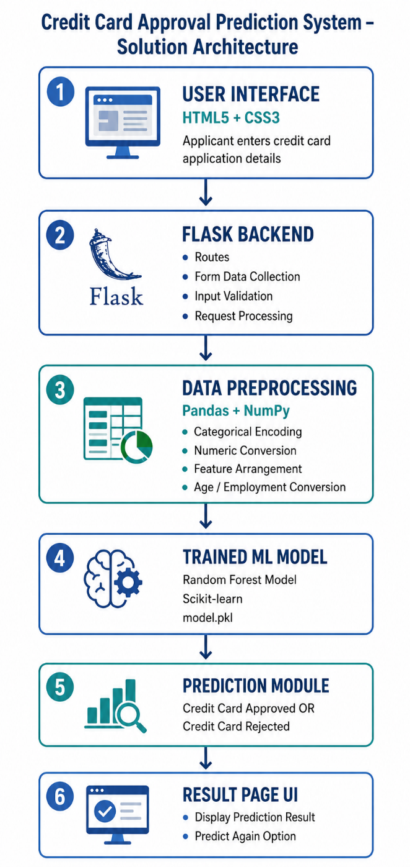
5. PROJECT PLANNING & SCHEDULING
5.1 Project Planning
The project was planned and executed using the Agile Scrum methodology, divided into 4 Sprints. Each Sprint focused on a specific functional module of the Credit Card Approval Prediction System, with Epics broken down into User Stories and estimated using Story Points.
Sprint-1: Data Collection & Data Preparation
Epic | User Story | Story Points
Data Collection | Gathering historical credit card application data (USN1) | 2
Data Collection | Loading data into the working environment (USN2) | 1
Data Preparation | Handling missing values in the dataset (USN3) | 3
Data Preparation | Encoding categorical features such as Gender, Income Type, Education (USN4) | 3
Data Preparation | Selecting the 12 key features required for prediction (USN5) | 2
Total Story Points in Sprint-1 = 11
Sprint-2: Model Development
Epic | User Story | Story Points
Model Development | Splitting dataset into training and testing sets (USN6) | 1
Model Development | Training a Random Forest Classifier (USN7) | 5
Model Development | Evaluating model accuracy and confidence score (USN8) | 3
Model Development | Saving the trained model as a pickle file (USN9) | 2
Total Story Points in Sprint-2 = 11
Sprint-3: Flask Backend & Frontend UI Development
Epic | User Story | Story Points
Flask Backend Development | Setting up Flask application structure (USN10) | 2
Flask Backend Development | Creating prediction route/API (USN11) | 3
Flask Backend Development | Integrating ML model with Flask backend (USN12) | 3
Frontend UI Development | Designing home page/applicant details form (USN13) | 3
Frontend UI Development | Creating dropdown menus for categorical fields (USN14) | 2
Frontend UI Development | Designing prediction result page (USN15) | 3
Total Story Points in Sprint-3 = 16
Sprint-4: Input Validation, Testing & Deployment
Epic | User Story | Story Points
Input Validation | Implementing validation rules for income, age, employment, family members (USN16) | 3
Testing | Writing valid and invalid test cases (USN17) | 2
Testing | Executing test cases to verify functionality (USN18) | 2
Deployment | Deploying the web application (USN19) | 3
Total Story Points in Sprint-4 = 10
Overall Sprint Summary
Sprint | Total Story Points | Duration | Start Date | End Date
Sprint-1 | 11 | 6 Days | 01 Jun 2026 | 06 Jun 2026
Sprint-2 | 11 | 6 Days | 08 Jun 2026 | 13 Jun 2026
Sprint-3 | 16 | 6 Days | 15 Jun 2026 | 20 Jun 2026
Sprint-4 | 10 | 6 Days | 22 Jun 2026 | 27 Jun 2026
Velocity = Total Story Points / Number of Sprints Total Story Points = 11+11+16+10 = 48 Number of Sprints = 4 Velocity = 48/4 = 12 Story Points per Sprint
The team maintained a consistent velocity of 12 Story Points per Sprint, ensuring steady and predictable progress across all four sprints, from data collection through to final deployment.

6. FUNCTIONAL AND PERFORMANCE TESTING
6.1 Performance Testing
Functional and performance testing was carried out to validate that the Credit Card Approval Prediction System works correctly and efficiently under various conditions. A total of 12 test cases were executed, covering both functional correctness and system performance.
Functional Test Cases
Test Case ID | Scenario | Expected Result | Result
FT-01 | Dropdown input validation (Gender, Income Type, Education, etc.) | Valid inputs accepted, errors shown for empty/invalid selection | Pass
FT-02 | Number input validation (Annual Income, Age, Children, Employment Years) | Accepts valid values, error shown for out-of-range values | Pass
FT-03 | Prediction generation on submitting complete applicant details | Correct approval/rejection result generated | Pass
FT-04 | Model loading check on server start | Trained Random Forest model loads without errors | Pass
FT-05 | Field dependency validation (Employment vs Age, Children vs Family Members) | Appropriate error message displayed for invalid combinations | Pass
FT-06 | Applicant summary display on result page | All entered details displayed accurately in summary table | Pass
FT-07 | Prediction timestamp check | Correct current date and time displayed with result | Pass
FT-08 | "Predict Again" button functionality | Returns to input form without errors or page reload issues | Pass
Performance Test Cases
Test Case ID | Scenario | Expected Result | Result
PT-01 | Response time for prediction generation | Should be under 3 seconds | Pass (1–2 seconds)
PT-02 | Model prediction speed under repeated requests | Model should not slow down or crash | Pass
PT-03 | Concurrent user load test | Application should handle multiple simultaneous submissions smoothly | Pass
PT-04 | Home page/form load time | Should load under 2 seconds | Pass (Under 1 second)
All 12 functional and performance test cases passed successfully, confirming that the application performs accurately, validates inputs correctly, and delivers predictions within acceptable response times, even under concurrent usage.

7. RESULTS
7.1 Output Screenshots
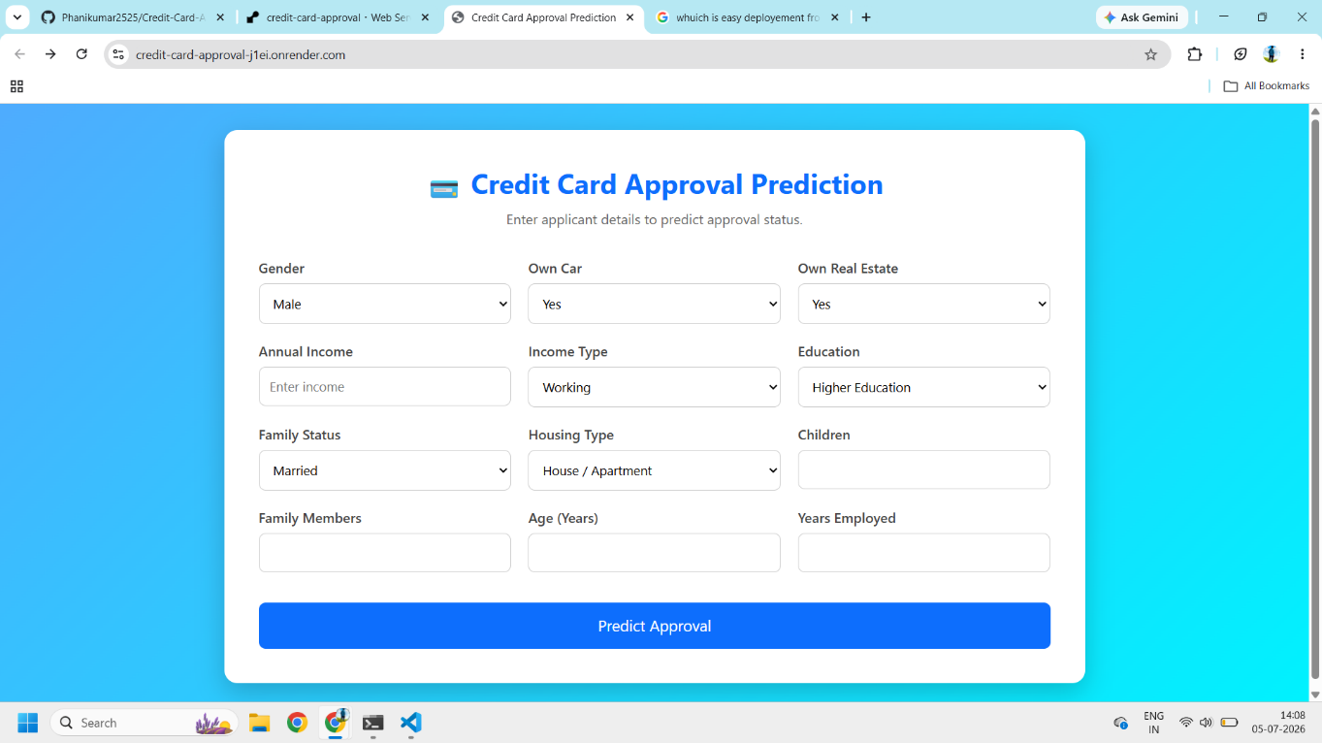
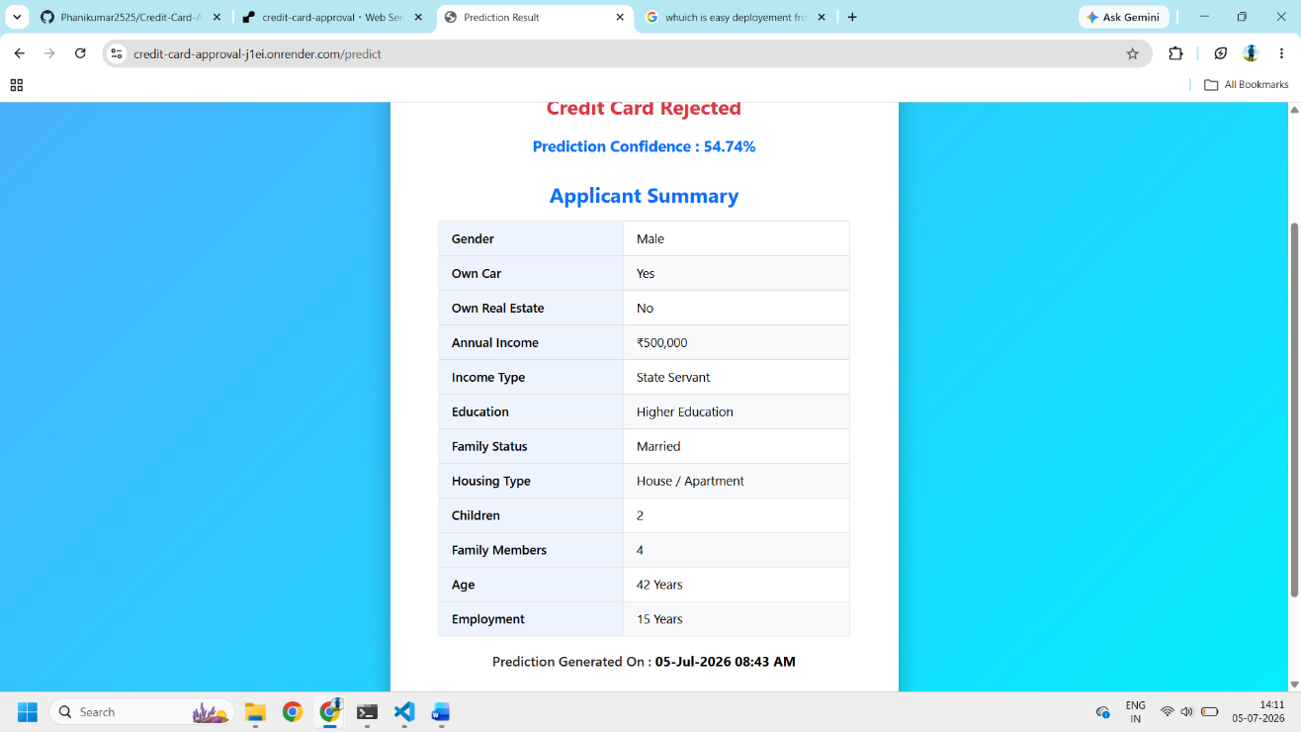

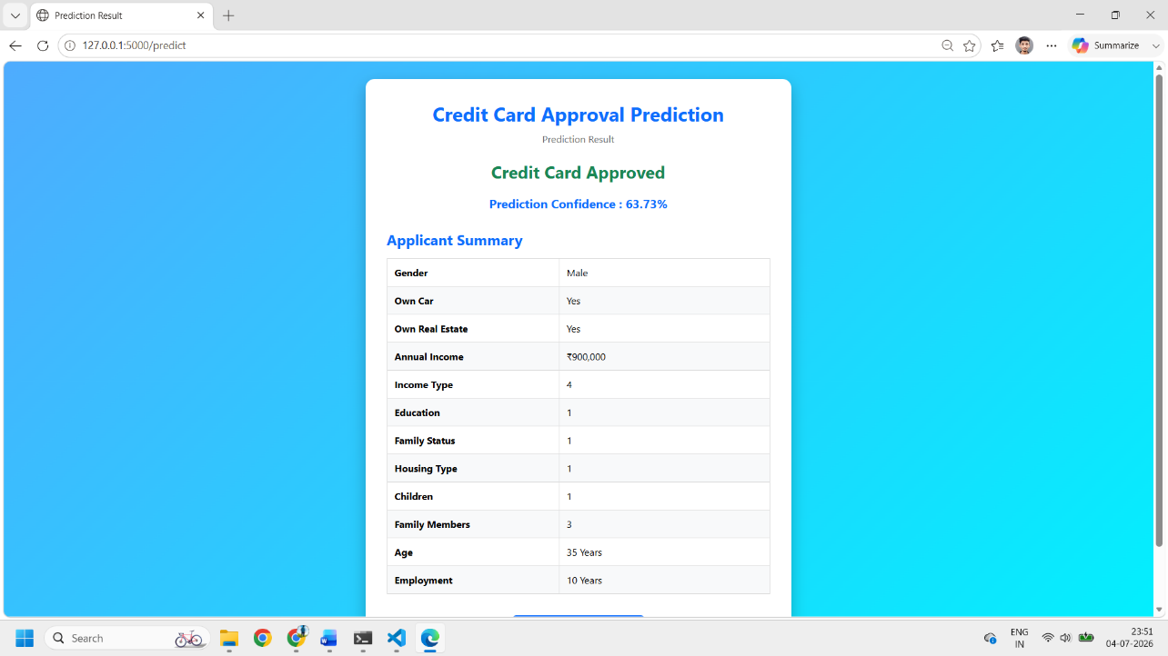

8. ADVANTAGES & DISADVANTAGES
Advantages:
- Provides instant credit card approval predictions.
- Reduces manual effort and human bias in decision-making.
- UsEr-friendly interface with dropdowns and validation reduces input errors.
- Displays confidence score for better transparency.
- Lightweight and easy to deploy using Flask.
- Can be integrated into larger banking systems as a pre-screening layer.
Disadvantages:
- Model accuracy depends heavily on the quality and volume of training data.
- Does not account for real-time credit bureau checks (e.g., CIBIL score).
- Predictions are based on historical patterns and may not generalize to all real-world cases.
- Currently lacks user authentication and data storage for application history.
- Model may need periodic retraining to stay accurate with changing financial trends.

9. CONCLUSION
This project demonstrates how Machine Learning and Flask can be integrated to automate the credit card approval process. The Random Forest model helps predict approval decisions quickly and consistently based on applicant data. The application also provides a user-friendly interface with input validation, prediction confidence, and an applicant summary, making it practical and easy to use. Overall, the project showcases the complete machine learning workflow, including data preprocessing, model training, prediction, and web deployment, making it a suitable mini project and a strong addition to a resume.

10. FUTURE SCOPE
- Integrate real-time credit score data (e.g., CIBIL, Experian) for more accurate predictions.
- Add user authentication and login system to maintain application history.
- Store applicant data and prediction history in a database (e.g., MySQL, MongoDB).
- Deploy the application on cloud platforms (AWS, Heroku, Render) for public access.
- Improve model accuracy using advanced algorithms like XGBoost or ensemble stacking.
- Add an admin dashboard to monitor overall approval trends and analytics.
- Implement multi-language support for wider accessibility.

11. APPENDIX
GitHub: https://github.com/Phanikumar2525/Credit-Card-Approval-Prediction
Dataset Link: Kaggle Credit Card Approval Prediction dataset
Project Demo Link:
https://drive.google.com/file/d/1XvwofS2LQFgHyQwkGramoYUqMFCi3Lzp/view?usp=sharing

